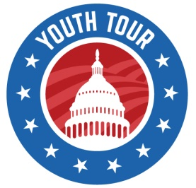
Rural Electric Cooperatives’
Youth Tour to Washington, D.C.
Tour Dates: June 19-26, 2021

Please complete this form and return with your essay to your local cooperative no later than:
Friday, November 27, 2020
Name: _______________________________________________________________________________
Address:______________________________________________________________________________
Street City, State Zip
Home Phone: ( )_______________________ Student Cell Phone: ( )____________________
Student E-mail Address:_________________________________________________________________
Age:___________
Name of Parent or Guardian:____________________________________________________________
Sponsoring Cooperative:________________________________________________________________
School Name: ____________________________________________ Grade: ______________________
T-Shirt Size (circle one): S M L XL XXL
If selected, are you available to attend the Youth Tour from June 19-26, 2021? (circle one):
YES NO

Please complete the following:
- List your school activities. Include any elected positions, special honors,
awards, and accomplishments from your high school career (class officer, plays,
athletics, music, etc.).

- List extracurricular activities and the years of participation, such as the 4-H,
FFA, church, community and service clubs. Indicate honors, awards and
accomplishments.

- ATTACH A SIGNED LETTER OF RECOMMENDATION (to be completed
by principal, guidance counselor, teacher or community leader) TO THIS
APPLICATION.
I will be a high school junior or senior in the fall of 2021 and my parent(s)/guardian(s) are receiving electrical service from ___________________ Cooperative. I understand that I am required to submit an essay on the topic:
“How has reliable electricity benefited you and your community through the COVID-19 pandemic?”
I have read and understand that my application and essay are to be submitted to __________________ Cooperative no later than November 27, 2020 or I will not be considered for the Youth Tour program.
I understand that if I am selected to represent ________________ Co-op and, for some unforeseen reason, I am not able to attend the 2021 Youth Tour, I must notify __________________ Co-op immediately so that an alternate may make the trip to Washington D.C.
I authorize _________________ Co-op to use the above information along with photos of me for publicity purposes of the sponsoring cooperative and Montana Electric Cooperatives’ Association.
Applicant’s Signature: _________________________________________ Date: __________________
Parent or Guardian’s Signature: _________________________________ Date:___________________

