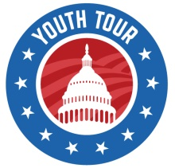
Youth Tour 2021
Dates: June 20-26, 2021 with a mandatory orientation meeting in Great Falls on June 19, 2021
The essay topic for the 2020 Youth Tour is:
“How has reliable electricity benefited you and your community through the COVID-19 pandemic?”
Date essay due at your local cooperative: November 27, 2020 – contact your local cooperative for
details; some cooperatives do not use the essay contest to select their participant.
YOUTH TOUR CONTEST RULES
- The student must be a junior or senior in high school in the fall of 2021. (Currently a sophomore or junior).
- Student cannot be a prior winner of the youth tour.
- The student and/or parent or guardian must be served by a rural electric cooperative that is a
member of Montana Electric Cooperatives’ Association.
- The student must write an essay on the following topic (for those cooperatives using the essay to select their representative):
  - “How has reliable electricity benefited you and your community through the COVID-19 pandemic?”
- Essays must include a cover page with the student’s name, address, telephone number and the
name of their rural electric cooperative and a copy of the attached application

